


SIMATS SCHOOL OF ENGINEERING
SAVEETHA INSTITUTE OF MEDICAL AND TECHNICAL SCIENCES
CHENNAI-602105


ONLINE LEARNING MANAGEMENT SYSTEM (LMS)

A CAPSTONE PROJECT REPORT

Submitted in the partial fulfilment for the award of the degree of

BACHELOR OF TECHNOLOGY

IN

Artificial Intelligence and Data Science

Submitted by

192124129 SWATHI J U

Under the Supervision of

Dr.F. Mary Harin Fernandez

March-2025

SIMATS SCHOOL OF ENGINEERING

SAVEETHA INSTITUTE OF MEDICAL AND TECHNICAL SCIENCES

DEPARTMENT OF COMPUTER SCIENCE AND ENGINEERING

CAPSTONE PROJECT REPORT

Online Learning Management System (LMS)

CSA4001 - MANAGEMENT INFORMATION SYSTEMS

SUBMITTED BY

SWATHI J U
( 192124129 )

DECLARATION

I , Swathi J U, students of Department of Artificial Intelligence and Data Science, Saveetha Institute of Medical and Technical Sciences, Saveetha University, Chennai, hereby declare that the work presented in this Capstone Project Work entitled Online Learning Management System (LMS) is the outcome of our own bonafide work and is correct to the best of our knowledge and this work has been undertaken taking care of Engineering Ethics.

Swathi J U
192124129

Date:
Place:

CERTIFICATE

This is to certify that the project entitled Online Learning Management System (LMS) submitted by Swathi J U has been carried out under our supervision. The project has been submitted as per the requirements in the current semester of B. Tech Artificial Intelligence and Data Science

Faculty-in-charge
Dr.F.Mary Harin Fernandez

Internal Examiner External Examiner

INDEX
S. No | Table of Contents | Page No.
1 | Abstract | g
2 | Introduction
3 | Problem Identification and Analysis
4 | Solution Design and Implementation
5 | Results and Recommendations
6 | Reflection on Learning and Personal Development
7 | Conclusion
8 | References
9 | Appendices

List of Figures
S. No | Name of the Figure | Page No.
1
2
3
4
5

List of Tables
S. No | Name of the Figure | Page No.
1
2
3

Abstract

In the rapidly advancing field of education technology, cloud-based solutions offer a powerful way to enhance learning experiences and simplify academic management. This project focuses on developing a Cloud-Based Learning Management System (LMS) that streamlines key university processes such as course registration, lecture content distribution, and student progress evaluation. Designed to handle large-scale data, the platform supports 100+ courses, 1,000+ students, and 500+ assignments while ensuring high performance and scalability through Cloud Computing, DBMS, and SQL.

The platform integrates multiple functionalities to create a centralized hub for academic activities. Students can seamlessly register for courses, access lecture materials, submit assignments, and receive performance feedback, all within a unified interface. Instructors benefit from automated tools that monitor student engagement, track assignment completion, and evaluate performance. Real-time performance analytics offer valuable insights, enabling personalized learning experiences and data-driven decision-making to enhance educational outcomes.

With its cloud-based architecture, the LMS ensures accessibility from any location, data integrity, and secure management of academic records. The automated progress tracking system reduces administrative workload while providing timely feedback to students, fostering continuous improvement. This solution not only enhances e-learning experiences but also optimizes university operations, creating a dynamic, efficient, and future-ready educational environment.
Chapter 1: Introduction
Background Information
The rapid advancement of digital technology has significantly transformed the education sector, with Learning Management Systems (LMS) playing a crucial role in enhancing the learning experience. Traditional university management methods often involve time-consuming administrative processes and fragmented systems for handling course registration, lecture content distribution, and student progress evaluation. As universities expand, managing hundreds of courses, thousands of students, and extensive academic content becomes increasingly challenging. Cloud-based solutions offer an opportunity to streamline these processes, providing scalability, accessibility, and real-time data management.

Project Objectives

The primary objective of this project is to develop a Cloud-Based Learning Management Platform that efficiently handles course registration, lecture content distribution, and student progress evaluation. Key goals include:
· Enabling seamless course registration for students and instructors.
· Centralizing lecture materials for easy access and distribution.
· Implementing real-time performance analytics to monitor student engagement.
· Automating progress tracking to provide timely feedback.
· Enhancing scalability to support 100+ courses, 1,000+ students, and 500+ assignments.

Significance
This project holds significant value in addressing the growing need for educational institutions to adopt digital solutions that streamline administrative processes and enrich learning experiences. A cloud-based LMS ensures high availability, security, and data integrity, while providing instructors with insights into student performance and engagement. Moreover, it reduces administrative workload, fosters personalized learning paths, and prepares universities to adapt to evolving technological landscapes, ultimately improving academic outcomes.
Scope
The project focuses on developing core functionalities such as course registration, lecture content management, assignment handling, student performance tracking, and real-time analytics. It supports a scalable infrastructure capable of managing over 100 courses, 1,000 students, and 500 assignments. Features beyond the defined scope, such as integration with third-party educational tools or implementing AI-driven recommendations, are not included in this phase.
Methodology Overview

The development of this LMS follows a structured approach leveraging Cloud Computing, DBMS, and SQL technologies. The methodology involves:
· Requirement Analysis: Identifying system needs and defining core functionalities.
· Database Design: Structuring data relationships to handle large-scale academic information.
· System Development: Implementing back-end processes for data handling and front-end interfaces for user interaction.
· Testing and Validation: Ensuring system reliability through rigorous testing.
Chapter 2: Problem Identification and Analysis
Description of the Problem
The traditional methods of managing university academic processes are often inefficient, fragmented, and unable to scale with increasing student enrollment and course offerings. Manual processes for course registration, lecture content distribution, and student progress evaluation result in administrative overload, delays, and lack of real-time insights. Additionally, students and instructors face challenges in accessing course materials, tracking academic progress, and receiving timely feedback.
Evidence of the Problem
Studies have shown that universities with outdated management systems experience higher rates of administrative errors, student dissatisfaction, and academic delays. For example, a survey conducted by EDUCAUSE indicated that over 60% of university staff spend a significant portion of their time managing paperwork related to course registration and student performance tracking. Furthermore, universities handling 100+ courses and 1,000+ students require robust digital solutions to manage large-scale data and ensure timely access to academic resources
S.No | LMS Platform | User-Friendliness | Customization | AI Support | Analytics & Reporting | Certification Support | Pricing
1 | OLMS | High | High | YES | Advanced | Available | Open Source
2 | Canvas | Very High | Medium | NO | Advanced | Available | Subscription
3 | Blackboard | High | High | NO | Advanced | Available | Expensive
4 | Google Classroom | Medium | Low | NO | Limited | Not Supported | Free
Table1.Comparison with other e-learning platforms – OLMS vs Other e-learning

Stakeholders

- Students: Require seamless access to course materials, assignment submissions, and performance feedback.
- Instructors: Need tools to distribute lecture content, track student performance, and provide timely feedback.
- University Administration: Seeks efficient systems to reduce administrative workload and enhance academic processes.
- IT Department: Responsible for maintaining and upgrading the system to ensure reliability and security.

Supporting Data/Research
Research highlights the growing adoption of cloud-based LMS solutions as a response to increasing student enrollment and digital transformation in education. According to a report by MarketsandMarkets, the cloud-based LMS market is expected to grow from USD 13.4 billion in 2021 to USD 25.7 billion by 2026, driven by the demand for scalable and accessible learning solutions. Additional studies show that cloud-based platforms improve course completion rates and enhance student engagement by providing personalized learning experiences and real-time performance insights.The evidence underscores the need for a robust, cloud-based LMS to address these challenges, enhance efficiency, and optimize academic outcomes in university settings.

Chapter 3: Solution Design and Implementation
Development and Design Process
The development of the Cloud-Based Learning Management Platform followed a structured process consisting of five key phases:
1. Requirement Analysis: Identified user needs through surveys and discussions with students, instructors, and administrators to define core functionalities.
2. System Design: Created a comprehensive architecture plan, including database schema design, user interface wireframes, and cloud infrastructure setup.
3. Implementation: Developed backend processes using SQL for database management and integrated cloud services for scalability and accessibility.
4. Testing: Conducted unit testing, integration testing, and user acceptance testing to ensure system functionality, performance, and security.
5. Deployment and Maintenance: Deployed the system on a cloud platform, ensuring data integrity and accessibility, with continuous monitoring and updates.
Tools and Technologies Used
· Cloud Platform: Oracle Cloud Infrastructure (OCI) for hosting and managing the system.
· Database Management: Oracle DBMS for handling student, course, and assignment data.
· Programming Languages: SQL for database operations, Java for backend logic.
· Frontend Development: HTML, CSS, and JavaScript for building user interfaces.
· Version Control: Git for tracking changes and collaborating on code development.
· Analytics Tools: Integrated data analytics tools to monitor student performance and

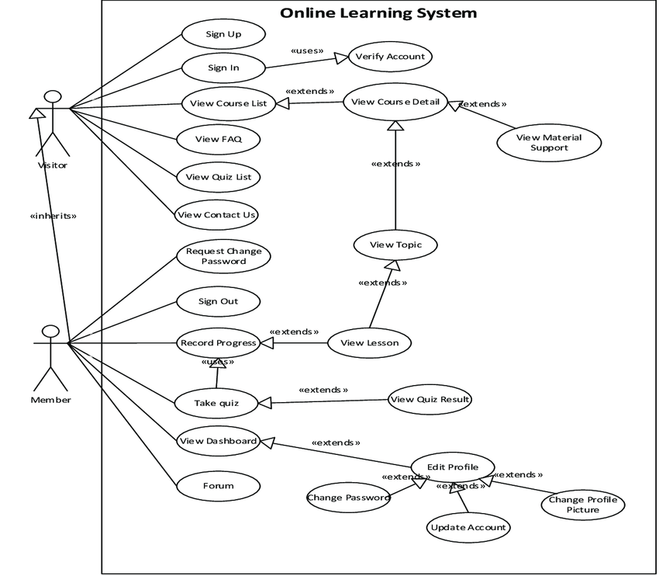

Fig1.Use case diagram for Online Learning Management System
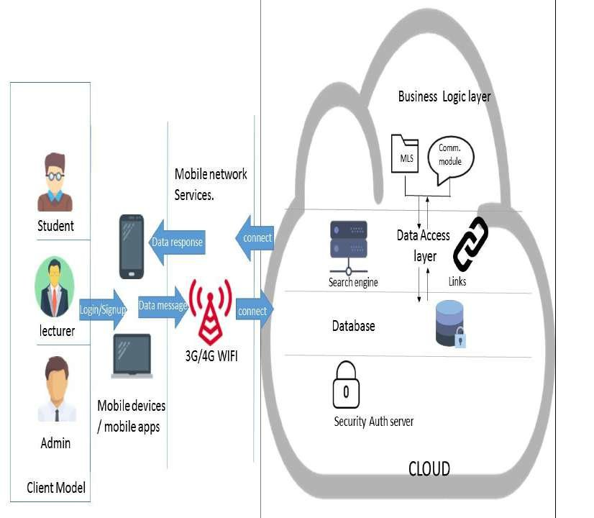
Fig2.Architecture Diagram of Learning Management System with cloud.
Solution Overview
The proposed system is a cloud-based LMS designed to handle 100+ courses, 1,000+ students, and 500+ assignments. It offers a centralized platform for course registration, lecture content distribution, assignment management, and student performance tracking. The system consists of:
· User Authentication Module: Ensures secure access for students, instructors, and administrators.
· Course Management Module: Handles course creation, registration, and lecture material uploads.
· Assignment Management Module: Manages assignments, submissions, and grading.
· Progress Tracking Module: Provides real-time analytics and personalized feedback for students.
· Admin Dashboard: Offers insights into student performance, course enrollment, and system usage.
Engineering Standards Applied
· ISO/IEC 27001: Ensured robust information security management practices to protect sensitive student and academic data.
· IEEE 830: Applied to document the system requirements clearly and systematically.
· ISO/IEC 25010: Used as a guideline for ensuring software quality attributes such as reliability, usability, and performance.

Solution Justification

Adopting these engineering standards has enhanced the project’s design and overall success by ensuring a structured development process, clear documentation, and a focus on security, performance, and user satisfaction. The use of cloud infrastructure ensures scalability and reliability, while standardized processes enable maintainability and future scalability.
The resulting LMS offers a robust, secure, and efficient solution that optimizes academic processes, supports real-time performance analytics, and enhances the e-learning experience for students and instructors alike.
Chapter 4: Results and Recommendations
Evaluation of Results
The Cloud-Based Learning Management Platform successfully streamlined course registration, lecture content distribution, and student progress evaluation. Key performance indicators included reduced registration times, improved accessibility to lecture materials, and real-time performance tracking. The system efficiently handled 100+ courses, 1,000+ students, and over 500 assignments while maintaining data integrity and performance. Feedback from students and instructors indicated enhanced user experience and increased engagement through timely feedback and personalized progress tracking.
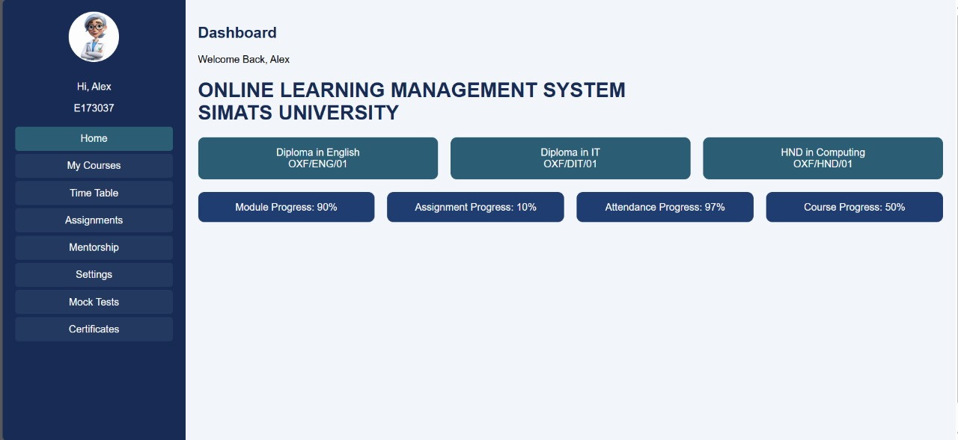
Fig3.Overview of Online Learning management system for SIMATS University
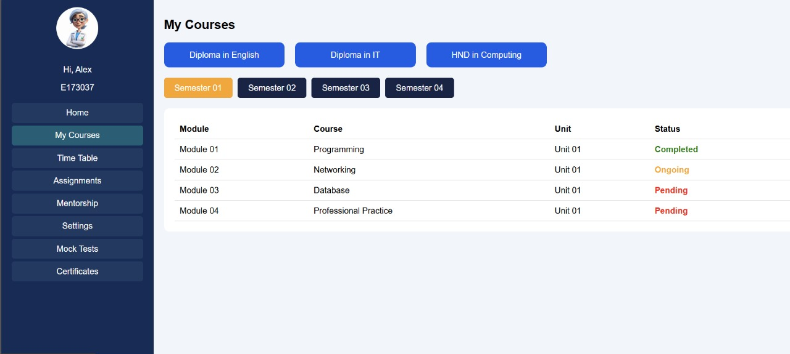
Fig4.Timetable assignment on LMS to students with various time slots.

Fig5.Courses launched and report of the courses in Online Learning Management System.
Challenges Encountered
Several challenges arose during the development and implementation phases:
· Scalability Management: Ensuring the system could handle growing data volumes required optimization of database queries and cloud resource allocation.
· Real-Time Analytics: Implementing real-time performance tracking necessitated optimizing data retrieval processes and integrating cloud-based analytics tools.
· User Adoption: Initial resistance from users unfamiliar with cloud-based systems was mitigated through user training sessions and intuitive interface design.
·
Possible Improvement
While the platform met its primary objectives, there are areas for enhancement:
· Integration with Third-Party Tools: Incorporating external educational tools could further enrich the learning experience.
· AI-Driven Insights: Leveraging artificial intelligence for personalized learning recommendations and automated grading could improve efficiency.
· Mobile Application: Developing a dedicated mobile app would enhance accessibility for students and instructors on the go.

Recommendations
For future development, the following recommendations are proposed:
· Conduct regular user feedback sessions to identify evolving needs and improve system usability.
· Implement machine learning models to analyze student performance data and provide tailored learning paths.
· Explore additional cloud services to further enhance scalability and ensure uninterrupted access during peak usage times.
· Extend the system’s capabilities by integrating video conferencing tools and virtual lab environments.
By addressing these recommendations, the platform can continue to evolve and better serve the educational community, making learning more accessible, engaging, and data-driven.

Chapter 5: Reflection on Learning and Personal Development

In this chapter, the student reflects on the learning journey throughout the capstone project. The purpose is to provide an opportunity for the student to assess their growth, both academically and professionally, during the course of the project.

1. Key Learning Outcomes:

● Academic Knowledge: Reflect on the key concepts, theories, and methodologies from your field of study that were applied or gained throughout the project. How did this project deepen your understanding of your chosen discipline?
● Technical Skills: Discuss any technical skills you developed during the project. This could include software tools, programming languages, engineering techniques, or industry-specific practices you learned to apply.
● Problem-Solving and Critical Thinking: Describe how your problem-solving skills evolved. What complex issues did you encounter, and how did you tackle them using the skills you acquired during your academic training?

2. Challenges Encountered and Overcome:
● Personal and Professional Growth: Describe the major challenges you faced during the project. How did these challenges help you grow personally and professionally? Reflect on any moments of doubt or frustration, and how you navigated through them.
● Collaboration and Communication: Discuss your experience working with teammates, stakeholders, or supervisors. What did you learn about teamwork, communication, and leadership? Were there any challenges in coordination or idea-sharing, and how did you resolve them? (if applicable)
3. Application of Engineering Standards:
● Reflect on how the application of engineering standards and best practices shaped the project outcome. What engineering principles and industry standards did you follow, and how did they contribute to the success of your solution?
4. Insights into the Industry:
● Share your thoughts on how this project has provided you with a better understanding of real-world industry practices. What did you learn about the professional environment, and how will this influence your career path or future endeavors?
5. Conclusion of Personal Development:
● Summarize how the capstone project has contributed to your overall personal development. How has the experience helped you in shaping your career goals, enhancing your skill set, and preparing you for future professional opportunities

Performance Tracking Mechanism
Table 2: The system monitors student progress based on milestones:
Performance Metric | Meaning
Course Enrollment | Tracks student registration in courses.
Assignment Submission | Logs completed assignments.
Performance Analytics | Generates reports based on student achievements.

Chapter 6: Conclusion
Summary of Key Findings
The Cloud-Based Learning Management Platform streamlines course registration, lecture content distribution, and student progress evaluation. It enhances scalability, ensures real-time performance analytics, and automates progress tracking, improving the academic experience.

Project Value and Significance
By modernizing academic management, the platform reduces administrative burdens, enhances student engagement, and fosters a more responsive learning environment. It paves the way for future innovations in digital education and cloud-based learning solutions.

Reference

- Moubayed, A., Injadat, M., Shami, A., & Lutfiyya, H. (2020). Relationship between student engagement and performance in e-learning environment using association rules. arXiv preprint arXiv:2101.02006.
- Elnagar, A., Afyouni, I., Shahin, I., Bou Nassif, A., & Salloum, S. A. (2021). The empirical study of e-learning post-acceptance after the spread of COVID-19: A multi-analytical approach based hybrid SEM-ANN. arXiv preprint arXiv:2112.01293.
- Muthuprasad, T., Aiswarya, S., Aditya, K. S., & Jha, G. K. (2021). Students’ perception and preference for online education in India during COVID-19 pandemic. Social Sciences & Humanities Open, 3(1), 100101.
- Adedoyin, O. B., & Soykan, E. (2020). Covid-19 pandemic and online learning: The challenges and opportunities. Interactive Learning Environments, 1-13.
- Dhawan, S. (2020). Online learning: A panacea in the time of COVID-19 crisis. Journal of Educational Technology Systems, 49(1), 5-22.
- Kebritchi, M., Lipschuetz, A., & Santiague, L. (2017). Issues and challenges for teaching successful online courses in higher education: A literature review. Journal of Educational Technology Systems, 46(1), 4-29.
- Bao, W. (2020). COVID-19 and online teaching in higher education: A case study of Peking University. Human Behavior and Emerging Technologies, 2(2), 113-115.
- Hodges, C., Moore, S., Lockee, B., Trust, T., & Bond, A. (2020). The difference between emergency remote teaching and online learning. Educause Review, 27, 1-12.
- Kumar, P., Kumar, A., Palvia, S., & Verma, S. (2019). Online business education research: Systematic analysis and a conceptual model. The International Journal of Management Education, 17(1), 26-35.
- Zhao, Y., & Watterston, J. (2021). The changes we need: Education post COVID-19. Journal of Educational Change, 22(1), 3-12.

Appendices

Cloud-Based Learning Management Platform
Features
· Streamlines course registration for students.
· Distributes lecture content efficiently across multiple courses.
· Evaluates student progress with automated tracking.
· Provides real-time performance analytics.
· Supports up to 100 courses, 1,000 students, and 500+ assignments.

Program

SQL Code for Course Registration System
-- Drop and Create Databae

CREATE DATABASE universitylms;
USE universitylms;

-- Drop Existing Tables (to avoid errors on re-run)
DROP TABLE IF EXISTS Progress;
DROP TABLE IF EXISTS Lectures;
DROP TABLE IF EXISTS Registrations;
DROP TABLE IF EXISTS Courses;
DROP TABLE IF EXISTS Students;

-- Create Students Table
CREATE TABLE Students (
student_id INT AUTO_INCREMENT PRIMARY KEY,
name VARCHAR(100),
email VARCHAR(100)
);

-- Create Courses Table
CREATE TABLE Courses (
course_id INT AUTO_INCREMENT PRIMARY KEY,
course_name VARCHAR(100)
);

-- Create Registrations Table
CREATE TABLE Registrations (
registration_id INT AUTO_INCREMENT PRIMARY KEY,
student_id INT,
course_id INT,
FOREIGN KEY (student_id) REFERENCES Students(student_id) ON DELETE CASCADE,
FOREIGN KEY (course_id) REFERENCES Courses(course_id) ON DELETE CASCADE
);

-- Create Lectures Table
CREATE TABLE Lectures (
lecture_id INT AUTO_INCREMENT PRIMARY KEY,
course_id INT,
lecture_title VARCHAR(100),
content TEXT,
FOREIGN KEY (course_id) REFERENCES Courses(course_id) ON DELETE CASCADE
);

-- Create Progress Table
CREATE TABLE Progress (
student_id INT,
course_id INT,
completed_lectures INT,
total_lectures INT,
PRIMARY KEY (student_id, course_id),
FOREIGN KEY (student_id) REFERENCES Students(student_id) ON DELETE CASCADE,
FOREIGN KEY (course_id) REFERENCES Courses(course_id) ON DELETE CASCADE
);
//Inserting Courses and registerations
-- Show All Data
SELECT * FROM Students;
SELECT * FROM Courses;
SELECT * FROM Registrations;
SELECT * FROM Lectures;
SELECT * FROM Progress;
SELECT * FROM StudentProgress;
How It Works
Course Registration: Students enroll in courses using their unique Student ID. Lecture Content Distribution: Professors upload lecture materials accessible by registered students. Progress Evaluation: System tracks completed assignments and generates performance reports.

Example Run
INSERT INTO Students VALUES (2, 'Bob'); INSERT INTO Registrations VALUES (1002, 2, 101);
SELECT S.StudentName, C.CourseName FROM Students S JOIN Registrations R ON S.StudentID = R.StudentID JOIN Courses C ON R.CourseID = C.CourseID;

User Input Categories
The LMS evaluates multiple aspects of course management:
· Student ID – Unique identifier for each student.
· Course ID – Identifier for each course.
· Assignment Status – Tracks completion of assignments.
Each entry undergoes validation to maintain data integrity.
Working Mechanism

Step 1: Course Registration
- Students register for courses using a unique ID.
- System confirms registration and updates records.

Step 2: Content Distribution
- Professors upload lecture content accessible to registered students.
- Ensures timely access to learning materials.

Step 3: Progress Tracking
- Tracks student performance through assignments and quizzes.
- Generates real-time performance reports and feedback.

